**REPUBLIC OF CAMEROON**

Peace-Work-Fatherland

**UNIVERSITY OF BUEA**

P.O. Box 63.

Buea, South West Region

CAMEROON

Tel: (237)33322134/33322690

Fax: (273)33322272



**FACULTY OF ENGINEERING AND TECHNOLOGY**

**DEPARTMENT OF COMPUTER ENGINEERING**

**COURSE**: INTERNET PROGRAMMING AND MOBILE PROGRAMMING. **CEF 440**

**COURSE COORDINATOR**: DR VALERY NKEMENI

**TASK 5:**

**UI Design and Implementation**

**GROUP 15 MEMBERS:**

1. EKANE CLINTON NTONGWE-FE22A198
2. ETUNDI ZAMBO JOSIANE-FE22A212
3. FAI NJI JR BAHTINYUY-FE22A215
4. NEBA NELLY ACHA-FE22A255
5. NGWA NATHAN NINJECK-FE22A268

Second semester Task 5 report, (B.ENG) Degree in Computer Engineering.

MAY

2025

Table of content

Introduction 3

What is the user interface (UI)? 3

Factors that designers must consider when designing user interfaces 3

Importance of well-designed user interfaces 4

The design process 4

Design framework 6

App identity 9

**Reason for Choosing the Name** 9

**Target Users** 9

**Core Values Represented:** 9

Visual design 10

Design Style and Approach 10

Color Scheme: Blue and White 10

Principles of Visual Design Applied 11

UI Design 12

Student pages 13

Lecturer pages 15

Main pages 18

Frontend implemenation 20

Technology Stack 21

Conclusion 23

Key Achievements 23

Impact and Value Proposition 24

Future Implications 25

Final Reflection 25

# Introduction

This report presents the user interface (UI) design and implementation process for a mobile-based attendance management system that uses facial recognition and geofencing technologies. The purpose of the application is to ensure quick, secure, and accurate student attendance tracking in real time while offering an intuitive and visually appealing user experience. This report outlines the design methodology, tools and frameworks used, and details specific UI tasks such as defining the app identity, creating the visual design, and implementing the frontend.

## What is the user interface (UI)?

User interface is the point of interaction or communication between auser and a computer system, software application or device. In software engineering, It is the part of a computer and its software that people can see, hear, touch, talk to. The layout (disposition) of an application's graphic, spoken, touch, or textual

controls in conjunction with the way the application responds to user activity.

In other words, how do you dispose graphics, spoken, etc. in such a way that

the application you have is in accordance with the user’s activity?.

The UI has two main components : the input and output.

## Factors that designers must consider when designing user interfaces

HCI designers must consider a variety of factors including human and

machine factors when designing a user interface. Two of these factors are:

**Human factor**

* What people want and expect, physical limitations and abilities people

possess.

* What people find enjoyable and attractive.

**Machine factors**

* Technical characteristics and limitations of the computer hardware

and software must also be considered.

* How information processing systems work.

## Importance of well-designed user interfaces

* A well-designed interface is terribly important to users. It is their

window to view the capabilities of the software.

* It is also the vehicle through which many critical tasks are

presented. These tasks often have a direct impact on an

organization's relations with its customers, and its profitability.

* Poor design may even chase some people away from a system

permanently. It can also lead to aggravation, frustration, and

increased stress.

## The design process

The user interface design for the Mobile-Based Attendance Management System followed a structure user-centered process aimed at delivering a simple, efficient, and visually consistent application. Design process consisted of the following key phases :

**Phase 1: Requirements analysis**

This phase collects all of the necessary requirements for an interactive system

or device and yields a requirements specification or document as its outcome.

Requirements documents written specifically for user experience and

interaction design aspects are specified in terms of three main components

for requirement analysis:

* Functional requirements define specific behavior that the system should

support (often captured use cases)

* Non-functional requirements specify overall criteria governing the operation

of the interactive system without being tied to a specific action or behavior

(hardware, software, system performance, reliability, etc.)

* User experience requirements explicitly specify non-functional requirements

for the user interaction and user interface of the interactive system

(navigation, input, colors, etc.)

**Phase 2: Preliminary and detailed design**

The design phase consists of two stages: a preliminary stage where the high-level design or architecture of the interactive system is derived,and a detailed stage, where the specifics of each interaction are planned out.

**Phase 2.1: Preliminary design**

It consists of mapping out the high-level concepts such as the user, controls, interface displays, navigation mechanisms, and overall workflow. Preliminary design can also be called conceptual design, particularly in software engineering, because it is sometimes useful to organize the high level concepts into a conceptual map with their relations. Overall, this activity is about developing the mental model that users should have about the interactive system when using it.

**Phase 2.1: detailed design**

This stage entails planning out all the operations that take place between user and interactive system to a level where only implementation and technical details remain. It can be done by creating and refining a step-by-step list for the exchanges between the user and the system refinement of architectural components and interrelations to identify modules to be implemented separately.The refinement is governed by the nonfunctional requirements.

**Phase 3: Build and implementation**

The implementation phase is where all the planning gets turned into actual,

running code. The outcome from this phase is a working system, albeit not necessarily the final one Different platforms are used for interactive applications

Regardless of platform,we make sure to evaluate tool capabilities, ease of use,

ease to learn, cost, and performance.

**Phase 4: Evaluation**

In the final phase of the design cycle, developers test and validate the system implementation to ensure that it conforms to the requirements and design set out earlier in the process. A straightforward approach to validate a system specified using use cases is simply to check that each use case can be completed successfully Depending on this outcome, the design team can decide to proceed with production and deployment of the system or to continue another cycle through the design process.

The entire UI design process was driven by a focus on user experience, performance and reliability

## Design framework

The design framework is the specific flavor and approach the designer takes to conducting the design process. For our project the User-Centered Design(UCD) was adopted to guide the development of the mobile-based attendance management system’s user interface. User-centred design (UCD) prescribes a design process that primarily takes the needs, wants, and limitations of the actual end users into account during each phase of the design proces.

**Why User-Centered Design?**

The application deals with real-time attendance verification using facial recognition and geolocation. This demands that users interact with the system under time constraints , in real-world conditions, and on mobile devices with varying capabilities.To meet these demands, the interface need to be:

* Simple and intuitive, especially for first-time users.
* Fast and efficient, minimizing the number of steps required to complete tasks.
* Accessible, regardless of the user's technical proficiency.
* Context-aware, adapting to real-world use (e.g., location accuracy and lighting for face recognition).

UCD helped align the design with these needs by keeping the user at the center of every design decision.

**Key Principles of UCD Applied in This Project**

1. **Understand the Users**

The first step was to identify and understand the target users:

* Students: Need a quick and stress-free way to check in, along with access to their attendance history.
* Instructors: Require an overview of student attendance data, with filtering and monitoring capabilities.
* Administrators : May require data access or management features.

This informed the design of role-specific dashboards and simplified interactions.

1. **Involve Users in the Process**

Mock users (fellow students and test instructors) were involved in the design review and testing phases. Their feedback was used to refine UI elements such as:

Button placement, success/error messages ,data visibility (e.g., which attendance details to show on the main screen). Each iteration improved the system based on actual user reactions and usability observations.

**3. Design for Real Contexts**

The system was designed for real-world usage:

* Face recognition can be affected by lighting or camera quality—visual feedback helps users adjust.
* Geolocation accuracy can vary—status indicators show whether the app detects the correct location.
* Quick interactions were prioritized to ensure the check-in process takes under 5 seconds.

**Benefits of Using UCD**

* Minimized learning curve: Even first-time users can navigate the app without tutorials.
* Reduced user error: Visual cues and feedback guide users during check-in.
* Higher acceptance and satisfaction: The system is tailored to actual user needs and usage conditions.
* Gives designers a much-needed understanding of what their users actually

need since they are directly involved in the process

* Dramatically reduce both development time and cost when a careful attention is paid to UCD at the early stage of software development.
* UCD leads to systems that generate fewer problems during development and

have lower maintenance costs over their lifetimes.

* UCD is easy to learn, result in faster performance, reduce user errors

substantially, and encourage users to explore features that go beyond the

minimum required to get by.

* UCD reduces the risk of designers building the “wrong system”: a system that

the end users neither need nor asked for.

The User-Centered Design approach ensured that the mobile attendance management system was not only functionally complete but also highly usable and efficient. By prioritizing the real-world needs of students and instructors, the system achieves its goal of delivering a fast, secure, and intuitive attendance experience.

# App identity

The application is branded as “UniTrack”, a name derived from the combination of "University" and "Track" clearly reflecting its core purpose: tracking student attendance in a university setting.

**Reason for Choosing the Name**

* **Clarity:** The name immediately communicates the app’s primary function : that is tracking and managing attendance.
* **Professional Tone:** "UniTrack" sounds concise, modern, and suitable for academic environments.
* **Relevance:** The prefix "Uni" links the app directly to higher education institutions, while "Track" emphasizes real-time monitoring and data accuracy.
* **Memorability:** The name is short, easy to remember, and brandable important qualities for user recall and adoption.
* **Tagline:** “Track Presence. Build Discipline.”This tagline reinforces the app’s mission: enabling institutions to monitor student presence efficiently while promoting responsibility and accountability among students.

**Target Users**

* Students: who need a fast and transparent way to check in and track their own attendance history.
* Instructors: who require real-time monitoring of student participation and administrative tools for class management.

**Core Values Represented:**

**Transparency:** Real-time data and access for both students and instructors.

**Efficiency:** Fast check-in using biometric and location verification.

**Security:** Face recognition and geofencing prevent proxy or fraudulent attendance

**Accountability:** Encourages regular participation and punctuality.

# Visual design

The visual design of UniTrack was developed to reflect the values of professionalism, trust, and simplicity, while ensuring the user interface remains clean, accessible, and easy to navigate for students and instructors alike. The design approach emphasizes minimalism and clarity, supporting fast interactions without overwhelming the user with unnecessary visual elements.

## Design Style and Approach

For the designing of user interfaces the **Type of design to be privileged: invisible UI.** M. Golden Krishna, a designer at Samsung once said: “The best UI is no UI.” Designers are now embracing the need to become minimalists when they are asked to design digital products boiling functionality down to its essence. In this way of doing, font and colours play a crucial role in the design process.The UI follows a modern minimalist design approach based on Material Design guidelines. This includes:

* Consistent use of spacing, padding, and alignment
* Use of elevation and shadows to guide user attention
* Smooth transitions and animations to enhance user feedback
* Rounded elements and subtle icons to maintain a soft, modern aesthetic
* The design supports responsive behavior across different screen sizes, ensuring seamless use on both smartphones and tablets.

## Color Scheme: Blue and White

The primary colors used in the app’s design are blue and white. Blue was chosen as the primary color because it is commonly associated with:

* **Trust and reliability**, aligning with the app's secure facial recognition and GPS features
* **Professionalism and calmness**, ideal for academic environments
* **Technology and innovation** , reinforcing the app’s smart and modern functionality

White serves as the background/base color, chosen for:

* **Clean visual space** , allowing key elements to stand out
* **Simplicity and clarity** ,enhancing readability and reducing visual clutter
* **Accessibility** , improving contrast and overall user experience
* **Accent colors** (e.g., green for success, red for errors) are used sparingly to support notifications and alerts without overwhelming the interface.

## Principles of Visual Design Applied

To ensure the interface is both usable and aesthetically pleasing, the following visual design principles were applied:

**Hierarchy**  
Important elements like the “Check-In” button or attendance status are given visual weight through size, color contrast, or placement to guide the user’s eye.

**Consistency**  
Fonts, button styles, icons, and colors are reused consistently across all screens, reducing cognitive load and improving the user’s confidence in navigating the app.

**Alignment and Spacing**  
Clean grid layouts and consistent spacing between elements create a sense of order and balance, making the interface look organized and professional.

**Contrast**  
High contrast between text and background (e.g., blue on white, black on white) ensures readability, especially in daylight or classroom settings.

**Feedback and Affordance**  
Visual feedback is provided when users interact with buttons, submit attendance, or encounter errors. This helps users understand the system's responses and build trust in its functionality.

**Simplicity**  
The design avoids unnecessary visual elements or distractions. Each screen is focused on a single task, making navigation and usage intuitive and efficient.

## UI Design

**Figma** is a **collaborative interface design tool** used for creating user interfaces (UI), user experiences (UX), prototypes, and wireframes mostly for , mobile apps, and digital products.

### Key Features of Figma:

* **Browser-based**: It runs in a web browser (no need to install software), but also offers a desktop app.
* **Real-time collaboration**: Multiple people can design and edit in the same file at the same time (similar to Google Docs).
* **Design + Prototyping**: You can design screens and also create interactive prototypes without switching tools.
* **Version control**: Automatically saves versions, so you can go back and see changes.
* **Cross-platform**: Works on Windows, macOS, Linux, and even Chromebooks since it’s web-based.
* **Plugins and widgets**: Extend Figma’s functionality with add-ons like icon libraries, accessibility tools, and code exporters.

For our attendance management system we designed the various pages for our different target users.

## Student pages

For our attendance management system we designed the following pages for the students;

* Login and sign up page
* Course registration page
* Registered course page
* Session page
* Face recognition page
* Home page
* Scan your face page

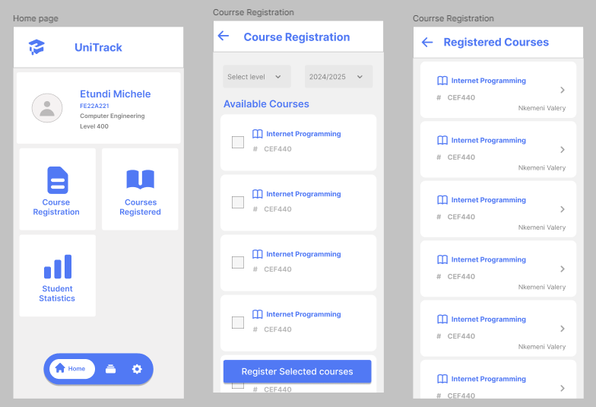

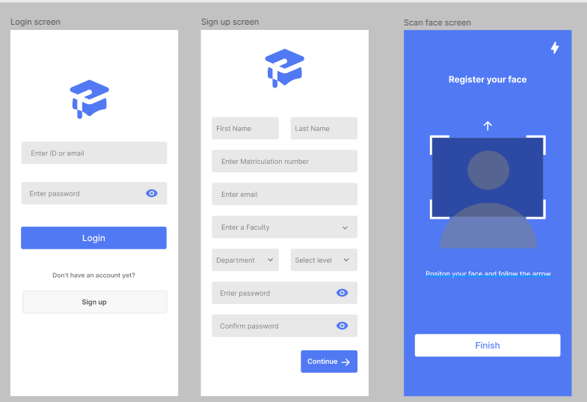

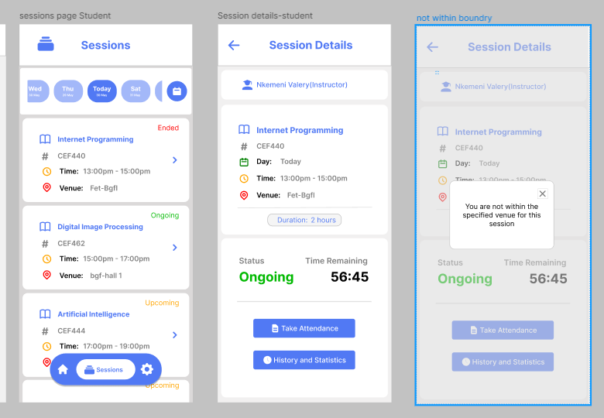

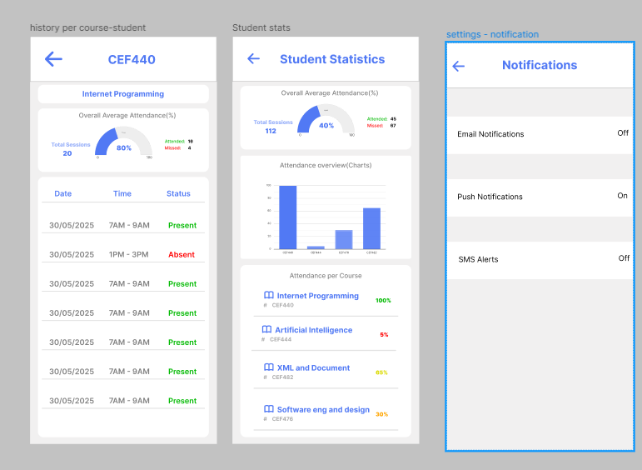

## Lecturer pages

For our attendance management system we designed the following pages for the lecturer;

* View course page
* Attendance history page
* Filter page
* Home page

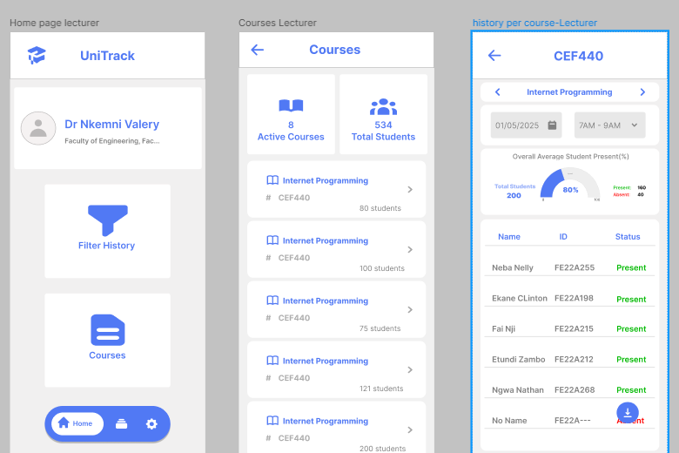

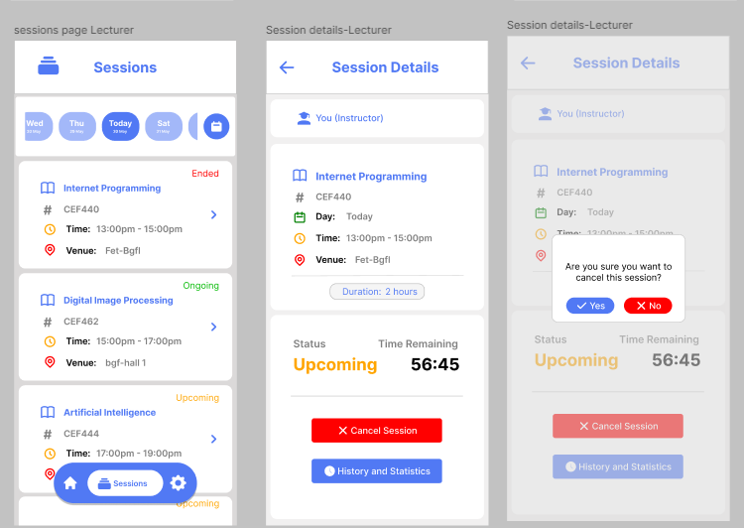

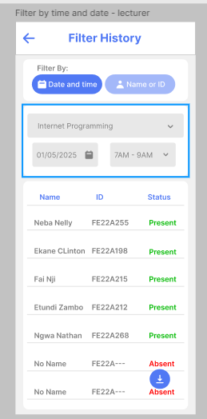

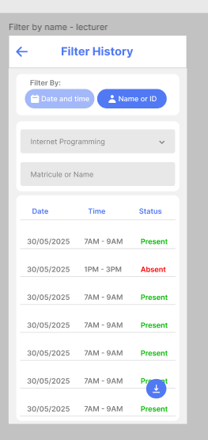

## Main pages

* Welcome page
* Splash screen page
* Profile setting page

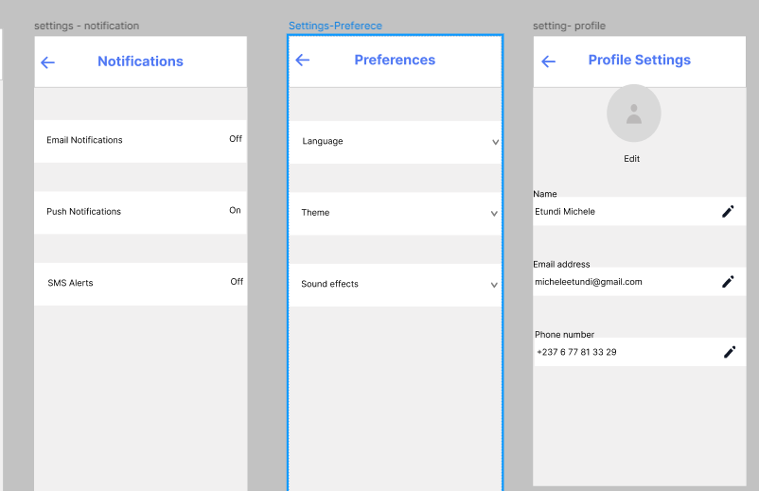

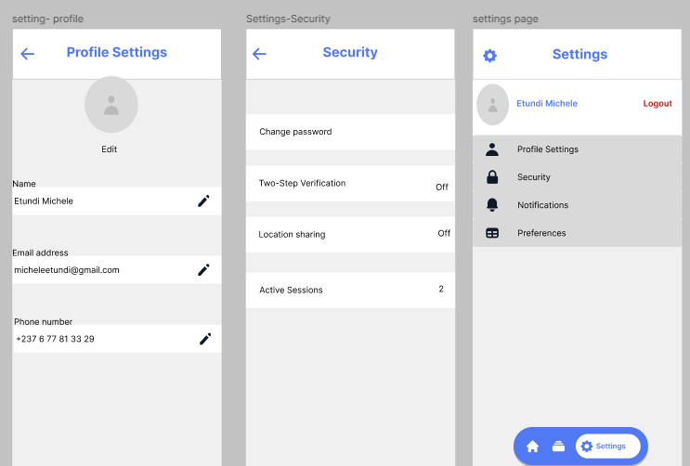

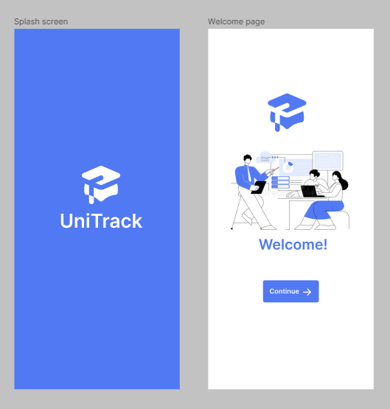

**Link to our figma design**

<https://www.figma.com/design/ZmRrZNL2ZjdVCzCCU3EYsj/ui-1.0?node-id=0-1&t=XnlDkxK0HI8lfym1-1>

# Frontend implemenation

The frontend of UniTrack was developed with a focus on performance,responsiveness, and clean UI rendering to ensure seamless interaction across mobile devices. The implementation followed modern mobile development standards and was built using React-Native, a cross-platform framework that enables consistent experiences on both Android and iOS.

## Technology Stack

* **Framework:** React Native

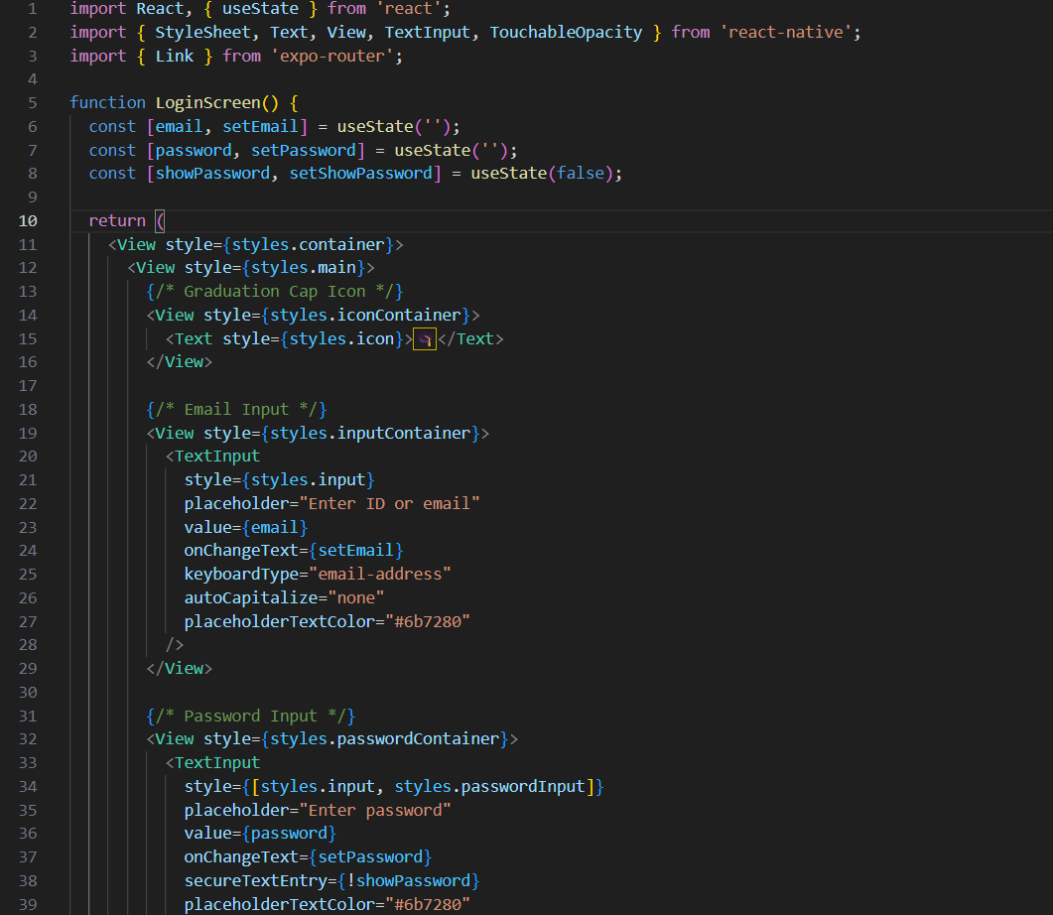

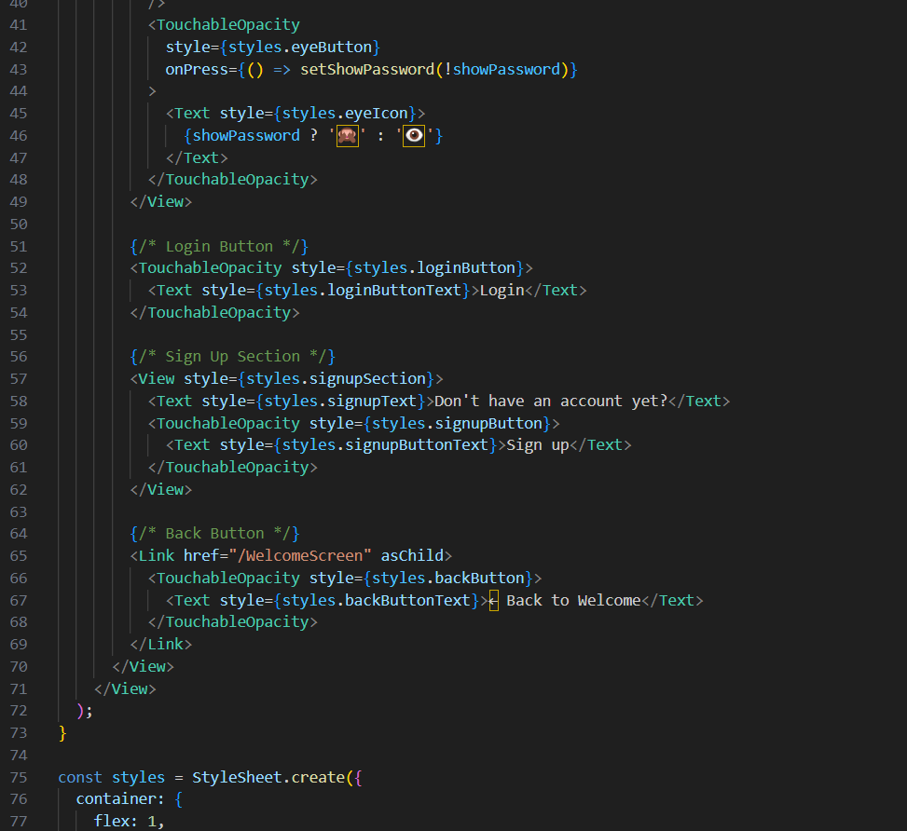

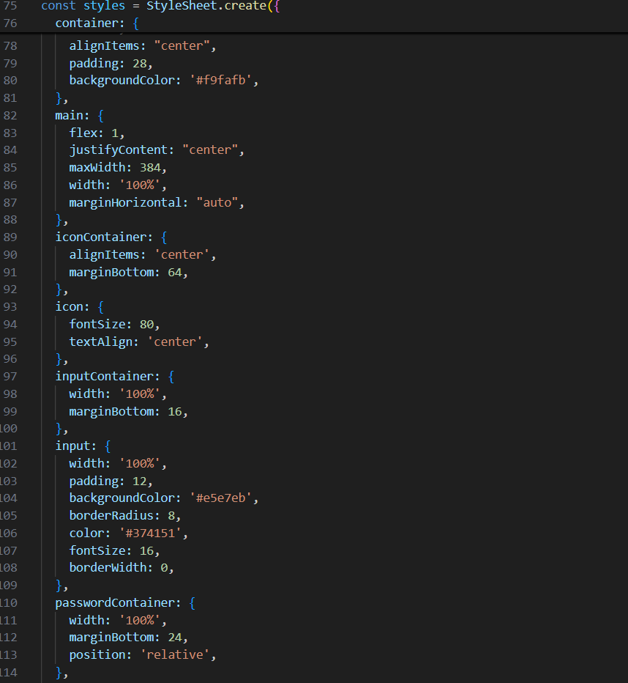

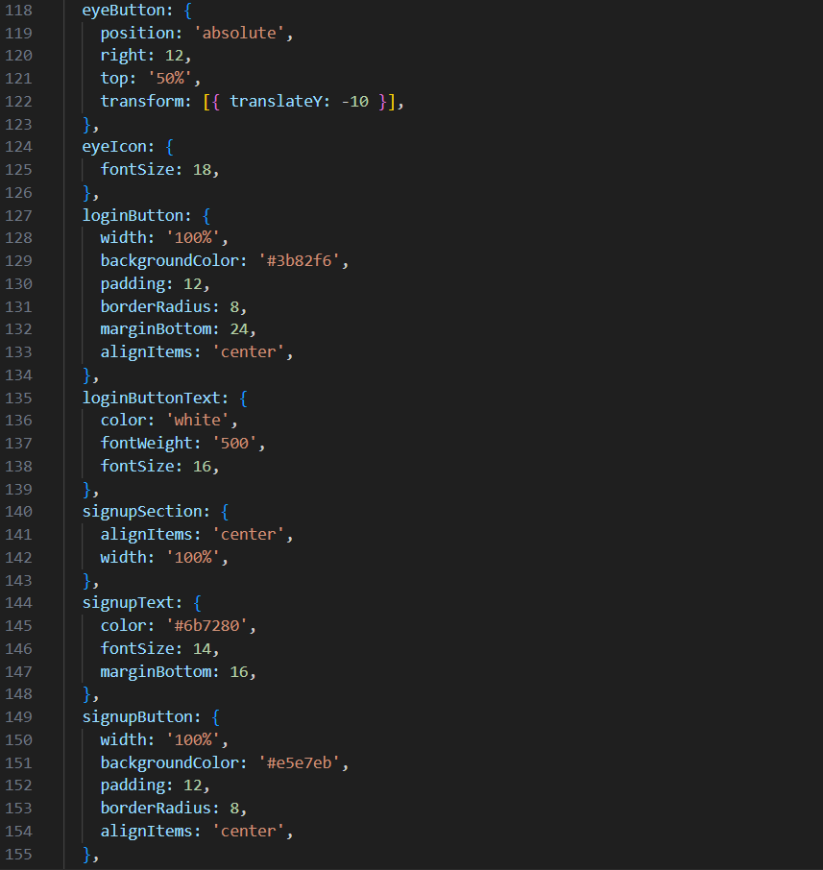



Inserted above is the implementation code for our loginscreen using reactnative

# Conclusion

The development of UniTrack represents a comprehensive approach to modernizing attendance management in academic institutions through the integration of facial recognition technology and geofencing capabilities. This project successfully demonstrates how user-centered design principles can be applied to create an intuitive, efficient, and secure mobile application that addresses the real-world challenges faced by both students and instructors in traditional attendance systems.

## Key Achievements

The project accomplished several significant milestones that validate its effectiveness as a modern attendance solution:

**User-Centered Design Implementation**: The adoption of User-Centered Design (UCD) methodology ensured that the application truly serves its intended users. By involving students and instructors throughout the design process, the team created an interface that minimizes learning curves and maximizes user satisfaction. The focus on real-world usage contexts, such as varying lighting conditions for facial recognition and location accuracy challenges, resulted in a robust system that performs reliably under diverse conditions.

**Professional Visual Identity**: The establishment of "UniTrack" as a brand, with its clear value proposition of "Track Presence. Build Discipline," successfully communicates the application's purpose while maintaining a professional academic tone. The minimalist design approach, featuring a blue and white color scheme, effectively conveys trust, reliability, and technological sophistication—qualities essential for an application handling sensitive attendance data.

**Comprehensive UI Coverage**: The design process yielded a complete set of user interfaces covering all essential user journeys. From student registration and course enrollment to instructor monitoring and attendance filtering, the application provides a holistic solution that addresses the needs of all stakeholders in the academic attendance ecosystem.

**Technical Foundation**: The implementation using React Native demonstrates a forward-thinking approach to mobile development, ensuring cross-platform compatibility while maintaining native performance. This technical choice positions the application for scalable deployment across diverse institutional environments.

## Impact and Value Proposition

UniTrack addresses critical pain points in traditional attendance systems by offering:

* **Enhanced Security**: The combination of facial recognition and geofencing virtually eliminates proxy attendance and fraudulent check-ins
* **Improved Efficiency**: The streamlined 5-second check-in process significantly reduces class disruption time
* **Real-time Transparency**: Both students and instructors gain immediate access to attendance data, promoting accountability and enabling proactive intervention
* **Administrative Relief**: Automated attendance tracking reduces manual record-keeping burden on educational staff

## Future Implications

The success of this project demonstrates the potential for technology-driven solutions to transform traditional academic processes. The methodology and design principles employed in UniTrack can serve as a template for developing other educational management systems, particularly those requiring high security and user adoption rates.

The emphasis on accessibility and user experience ensures that the system can adapt to various institutional contexts, from small colleges to large universities, making it a scalable solution for the broader educational sector.

## Final Reflection

UniTrack exemplifies how thoughtful design, user-centered methodology, and appropriate technology selection can converge to create solutions that are not only functional but genuinely beneficial to their users. The project's success lies not just in its technical capabilities, but in its deep understanding of user needs and its commitment to creating an experience that enhances rather than complicates the educational process.

By prioritizing simplicity, security, and user satisfaction, Group 15 has developed a system that stands as a testament to the power of well-executed user interface design in creating meaningful technological solutions for real-world challenges. The UniTrack project serves as a model for how academic projects can translate theoretical knowledge into practical applications that have the potential to make a lasting impact on educational institutions.